- Use MathCAD 4.0 or 5 only. No other version would open using university MathCAD.

NOTE: Use the physical constants that you need from the tables and graphs shown after the Exam problems. Use only the constants you need.

Problem 1
Design a 3C-SiC p⁺-n-p transistor. The structure is similar to the figure below. The base doping is 1.0x10¹⁷ cm⁻³ and the collector doping is 1x10¹⁶ cm⁻³. The data sheet of the 3C-SiC material indicates that the material has a bulk recombination center of 1.0x10¹⁵ centers/cm³ and a capture cross-sections of 2x10⁻¹⁵ cm² for both the electrons and holes.
- What would be the metallurgical base width, W_{B}, that gives a common base gain β=500, if Emitter-Base voltage of 2.2V and a Collector-Base voltage of ̶ 10V are applied.
- If the device area A_{r}=100µm², calculate the terminal currents I_{E}, I_{C}, and I_{B} and the Common Emitter gain α.

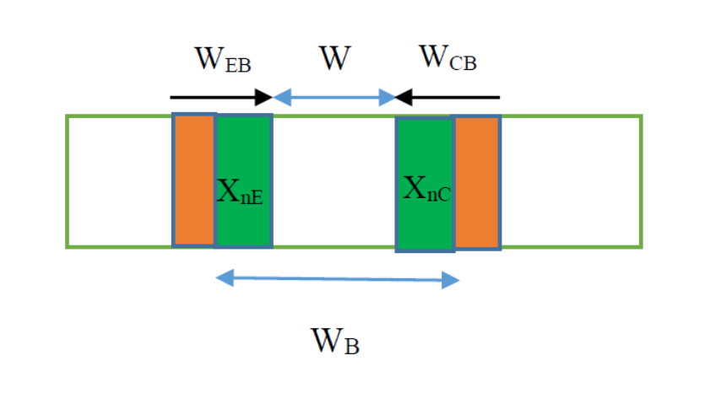

Problem 2:
You are asked to build a 4H-SiC n-channel MOSFET with a substrate doping of 1x10¹⁶ acceptor atoms/cm³. The device has a Chromium (Cr) Gate metal. The gate oxide is a Silicon Nitride (Si₃N₄) layer with a thickness of 200 Aº. The total oxide charge Q_{ox} =5x10¹⁰ qC/cm².
If the gate length is L=1 um and the gate width is Z=20 μm, find W_{max}, V_{FB}, V_{T}, the current at V_{D}=2V and V_{G}=5V, and the saturation current for the device at V_{G}=5V.

N_{A} is p-doped
n⁺
n⁺
n-MOSFET

Problem 3
Complementary CMOS technology uses n-MOSFET and p-MOSFET devices on the same chip to build integrated circuits. Here, the n-MOSFET is the one you designed in problem 2. Now you need to design the 4H-SiC p-MOSFET. The figure shown below shows a CMOS inverter.
The way the inverter built is to start with a p-4H-SiC substrate with the same doping as the substrate of Problem 2. Since the p-MOSFET requires n-type region, such region is created by implantation to produce net donor doping of 1x10¹⁵ donors/ cm⁻³. Then you dope the n⁺ and the p⁺ regions as shown below.
Because the devices are built on the same chip, both devices have the same gate metal, same gate oxide material, same oxide thickness, and same oxide charge density, as the device of Problem 2.
- What donor concentration you should implant to obtain a net doping of N_{D} = 1x10¹⁵ donors/cm³, for the n-type layer under the p-type gate, as shown below?
- Calculate V_{T}.
- It is required for the p-MOSFET to have saturation current I_{DSS} = -10 mA at V_{G} =-5V, what is the gate width Z, if the gate length, L= 1 μm?

n-type

p-type
n-MOSFET
p-MOSFET
p⁺
p⁺
n⁺
n⁺

Properties of cubic Si, Ge, 3C-SiC, GaAs, and GaN at 300K
Name of parameter | Si | Ge | GaAs | SiC (3C) | GaN
Energy gaps, E_{g} | 1.12 eV | 0.67 eV | 1.42 eV | 2.36 eV | 3.2 eV
Electron affinity | 4.05 V | 4 V | 4.07 | 3.8 V | 4.1 eV
Effective conduction band density of states, N_{C} | 2.86x10¹⁹ cm⁻³ | 1.04x10¹⁹ cm⁻³ | 4.7x10¹⁷ cm⁻³ | 1.689x10¹⁹ cm⁻³ | 1.2 x 10¹⁸ cm⁻³
Effective valence band density of states, N_{V} | 2.66x10¹⁹ cm⁻³ | 6x10¹⁸ cm⁻³ | 7x10¹⁸ cm⁻³ | 1.159x10¹⁹ cm⁻³ | 4.1 x 10¹⁹  cm⁻³
Effective mass for electrons | 0.26 | 0.082 | 0.063 | 0.68 | 0.13 m₀
Effective mass for holes | 0.69 | 0.28 | 0.57 | 0.6 | 1.4 m₀
Dielectric constant | 11.9 | 16 | 12.4 | 9.72 | 9.7

The Basic Properties of SiO2 and Si3N4
Insulator: | SiO2 | Si3N4
Structure | Amorphous | Amorphous
Melting Point (°C) | ~1600 | -
Density (g/cm3) | 2.2 | 3.1
Refractive index | 1.46 | 2.05
Dielectric constant | 3.9 | 7.5
Dielectric strength (V/cm) | 10⁷ | 10⁷
Infrared absorption band (μm) | 9.3 | 11.5 – 12.0
Energy gap | 9 | ~5.0
Thermal Expansion  coefficient (°C-1) | 5 x10⁻⁷ | -
Thermal conductivity (W/cm-K) | 0.014 | -
dc resistivity (Ω-cm)  at 25 °C  at 500 °C | 10¹⁴  10¹⁶  - | ~1014  ~2 x 1013

Work Functions for Metals

Work function of elements, in units of electron volt(eV).
Ag | 4.26 – 4.74 | Al | 4.06 – 4.26 | As | 3.75
Au | 5.1 – 5.47 | B | ~4.45 | Ba | 2.52 – 2.7
Be | 4.98 | Bi | 4.31 | C | ~5
Ca | 2.87 | Cd | 4.08 | Ce | 2.9
Co | 5 | Cr | 4.5 | Cs | 2.1
Cu | 4.53 – 5.10 | Eu | 2.5 | Fe: | 4.67 – 4.81
Ga | 4.32 | Gd | 2.90 | Hf | 3.9
Hg | 4.475 | In | 4.09 | Ir | 5.00 – 5.67
K | 2.29 | La | 3.5 | Li | 2.9
Lu | ~3.3 | Mg | 3.66 | Mn | 4.1
Mo | 4.36 – 4.95 | Na | 2.36 | Nb | 3.95 – 4.87
Nd | 3.2 | Ni | 5.04 – 5.35 | Os | 5.93
Pb | 4.25 | Pd | 5.22 – 5.6 | Pt | 5.12 – 5.93
Rb | 2.261 | Re | 4.72 | Rh | 4.98
Ru | 4.71 | Sb | 4.55 – 4.7 | Sc | 3.5
Se | 5.9 | Si | 4.60 – 4.85 | Sm | 2.7
Sn | 4.42 | Sr | ~2.59 | Ta | 4.00 – 4.80
Tb | 3.00 | Te | 4.95 | Th | 3.4
Ti | 4.33 | Tl | ~3.84 | U | 3.63 – 3.90
V | 4.3 | W | 4.32 – 5.22 | Y | 3.1
Yb | 2.60 ^{[13]} | Zn | 3.63 – 4.9 | Zr | 4.05

4H-SiC constants
Parameter | Value | Remarks
Energy Gap | 3.23 eV | 300K
Dielectric constant | 9.7 | 300 K
Effective electron mass m_{e} | 0.29 m_{o} | 300 K
Effective hole masses m_{p} | 0.98 m_{o} | 300 K
Electron affinity | 3.1 eV | 300 K
Lattice constant, a | 3.073 A | 300 K
Lattice constant, c | 10.053 A | 300 K
Breakdown Field (intrinsic) | 4x10⁶ V/cm | 300K

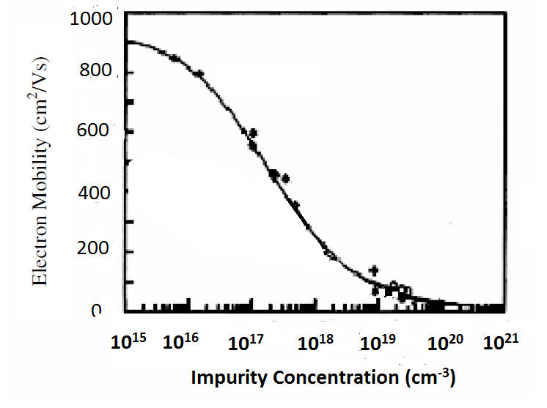
Electron Mobility
For 3C-SiC
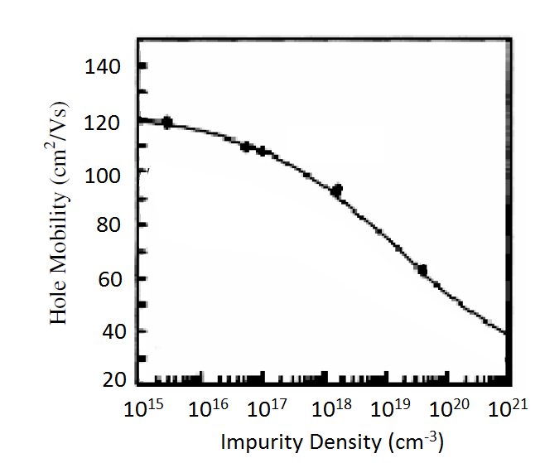
Hole Mobility
For 3C-SiC
Electron and Hole mobility for 3C-SiC

Electron
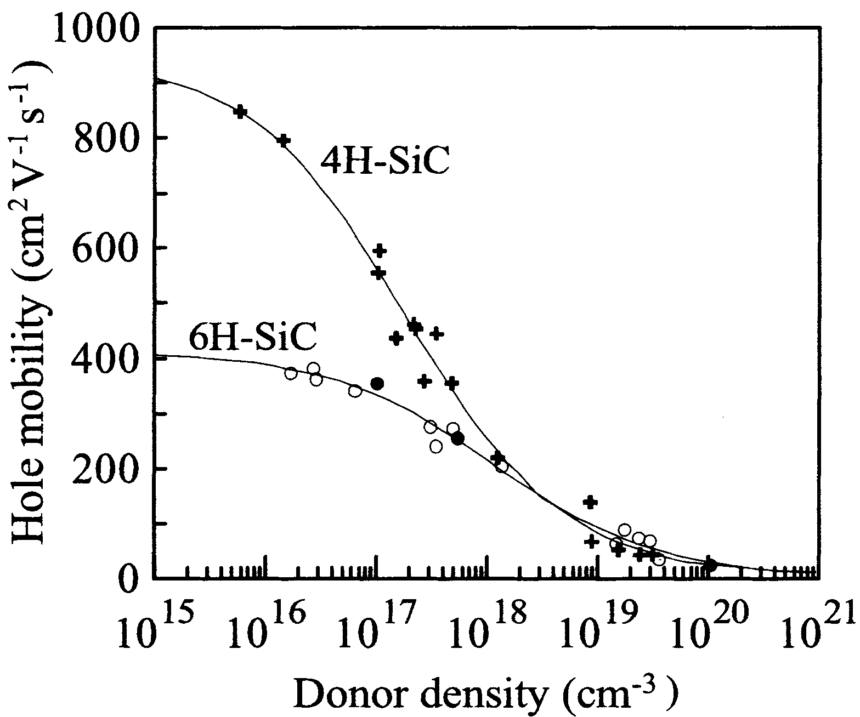
Electron Mobility for 4H-SiC and 6H-Sic

Hole
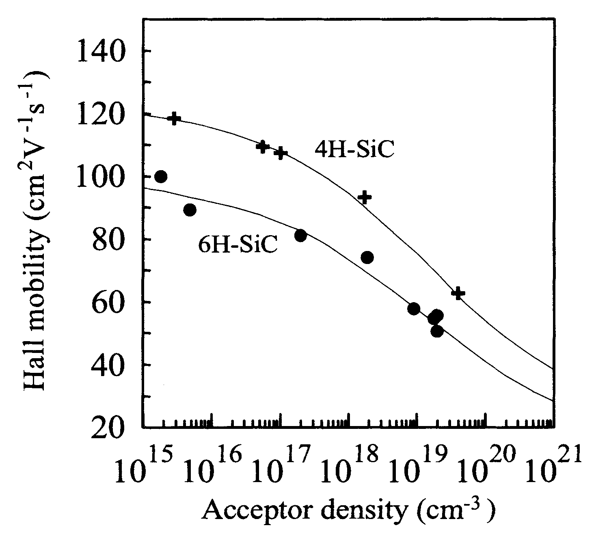
Hole Mobility for 4H-SiC and 6H-Sic

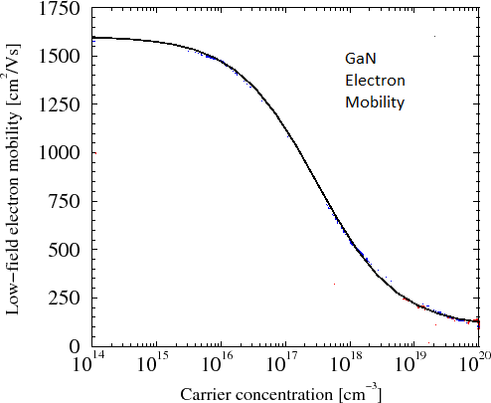
Electron Mobility of GaN vs. doping Concentration

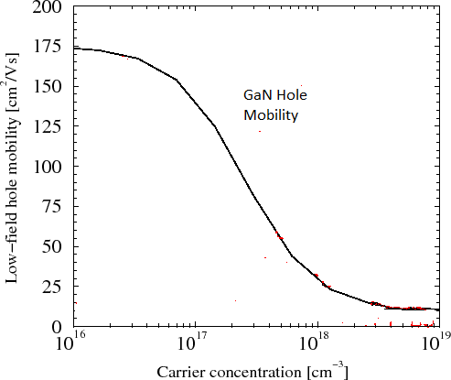
Hole Mobility of GaN vs. doping Concentration

